

Mawlana Bhashani Science & Technology University

Lab Report No : 05
Course Code : ICT3208
Course Title : Computer Network Lab
Report Name : Day time Udp client server protocol

Submitted by Submitted To
Name : Maskur Al Shal Sabil Nazrul Islam
Id: IT18021 Assistant Professor
3rd year 2nd Semester Dept of ICT
Session 2017-2018 MBSTU
Dept of ICT
MBSTU

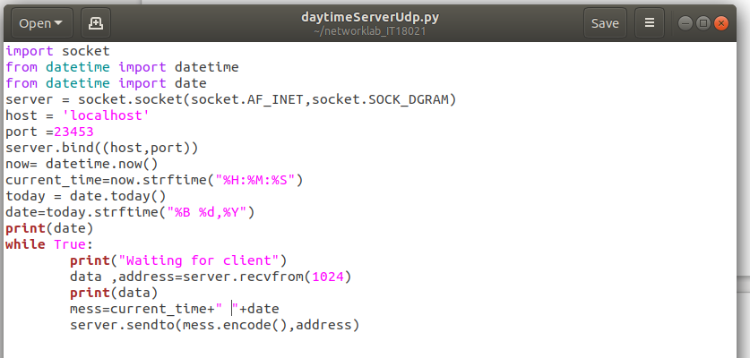
Code :
Server side code :

Explanation : here we use socket package and date time for current date and time . And we use SOCK_DGRAM for udp protocol instead of SOCK_STREAM . In Udp we doesn’t need to use the listen method since it is connection less protocol.

Client Side code:
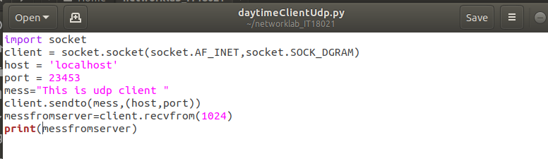
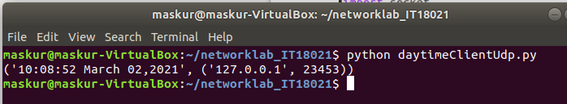
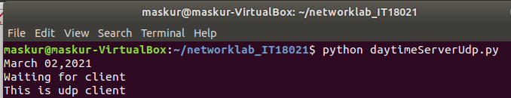
Output :

